**Comparison of Government Healthcare Expenditure and Out-of-Pocket Expenditure Across Countries in Different Socioeconomic Levels**

Sreeti Ravi

**Introduction**

This paper looks at the health expenditures of various countries around the world and compares that to the amount the people within the country have to spend. This comparison between a government’s healthcare expenditure and people’s out-of-pocket is to identify whether a government spending more on healthcare for its country equates to the people in that country having to spend less on healthcare out-of-pocket. Government expenditure on health is made up of the direct outlays earmarked for the enhancement of the health status of the population and the distribution of medical care goods and services among the population by central, federal, state, provincial, local and municipal authorities, extrabudgetary agencies and social security schemes (OECD). Out-of-pocket payments are defined as direct payments made by individuals to health care providers at the time-of-service use (Out-of-pocket). The countries chosen vary on the socioeconomic scale, so this also looks at the distribution of expenditure over different income levels to identify any trends.

**Background**

Much of the growth in health care spending over the past twenty years is linked to modifiable population risk factors such as obesity and stress. Rising disease prevalence and new medical treatments account for nearly two-thirds of the rise in spending. Growth in spending has also been linked to the rising use of prescription drugs and new medical innovation and treatments. Studies have shown that the United States spends a lot more on health care than any other high-income countries and that is due to higher administration expenses (Ducharme). The US spends 18 percent of its annual gross domestic product (GDP) on health and the next country with the highest health spending is Sweden at 12 percent. Most other countries spend around 9 percent of their GDP on health (Rizzo). The United States spends more per person on healthcare than the next 12 high income nations. Other wealthy countries spend about half as much per person on healthcare than the US (Bloom). Relative to wealth, the US spends a disproportionate amount on health care and is constantly an outlier when it comes to health spending.

We should care about rising health care costs and how much our government is spending on healthcare, especially now during a pandemic, because whether it is planned or not, everyone relies on healthcare services in one form or another. Most people go to at least one doctor regularly and will end up going at some points in their lives, even if not regularly. Citizens of a country should know what they are paying for with their tax money and should be educated on why exactly healthcare services in the US are so much more expensive than other countries. While these higher prices are being paid, life expectancy and quality of healthcare in the US has not increased proportionally and other countries have better statistics when looking at health factors, such as obesity, life expectancy and death rate to name a few.

**Methodology**

To address this problem, I did some research and looked at the possible data the World Health Organization (WHO) had on its website. I downloaded the data I used directly from the WHO from their Global Health Expenditure Database. This database requires you to choose options for ‘Indicators and data, ‘Countries’, ‘Years’ and ‘Units of expenditures’. I chose the ones that directly addressed the topic I was researching. The options I chose for indicators were: Current Health Expenditure (CHE) as % Gross Domestic Product (GDP), Domestic General Government Health Expenditure (GGHE-D) per Capita in US$ and Out-of-Pocket Expenditure (OOPS) per Capita in US$ as the indicators. I chose a wide range of countries on the socioeconomic scale for the countries option and chose all the years that were available from the options. For units of expenditure I chose ‘in current US$ per capita.’ This file was saved as nha_indicators.csv.

I created and configured a virtual machine in Jetstream using the image that was provided for the last project. I created a folder called ProjectB and did all my work for this project in that folder.



For the MongoDB portion, I used the ProjectA database because it already existed and I created a new collection called ‘indicators’ in MongoDB. I copied the data file that I downloaded from the WHO website called nha_indicators.csv into the virtual machine using the web shell. I also created a Python file called script.py that included code to download the nha_indicators.csv file and convert it from a .csv to .json when called. This file was also copied into the virtual machine using the web shell. To visualize the data at the final stage of the pipeline, I used PowerBI.

**Results and Discussion**

The visualizations helped see trends in the data between the money a country spent on healthcare versus the money people had to spend out-of-pocket.

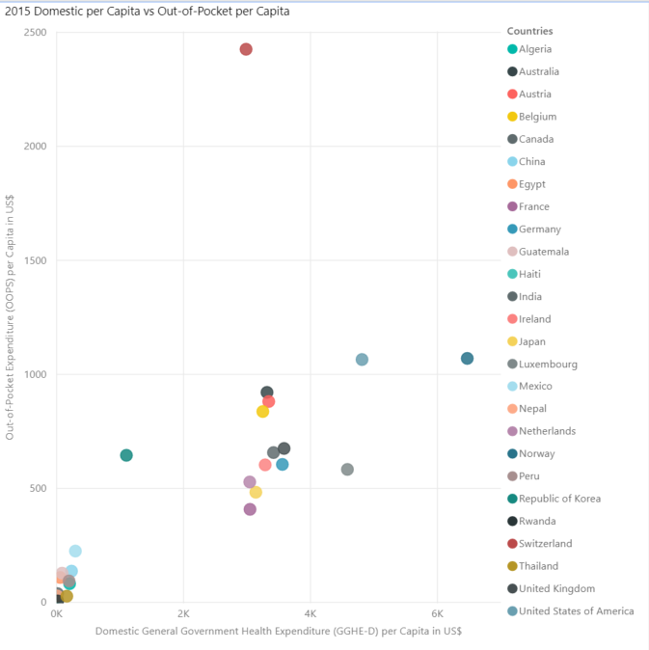

This scatterplot shows that Switzerland has the highest expenditure out-of-pocket but not by the government, while Nepal has the smallest of both. The US is not necessarily the only outlier like my research has suggested. While this represents each country’s data, it does not show socioeconomic levels of each country so this scatterplot below shows the differences in spending by the income groups that countries belong to. Here, it is visible that the higher income groups have a higher health expenditure by the government and higher out-of-pocket costs. The other three income groups are all in the bottom left-hand corner because they have the smallest amount of spending by both the government and people. This graph shows a clear distinction with spending and income groups that suggest more developed countries have a higher general government health expenditure per capita and higher out-of-pocket expenditure per capita.

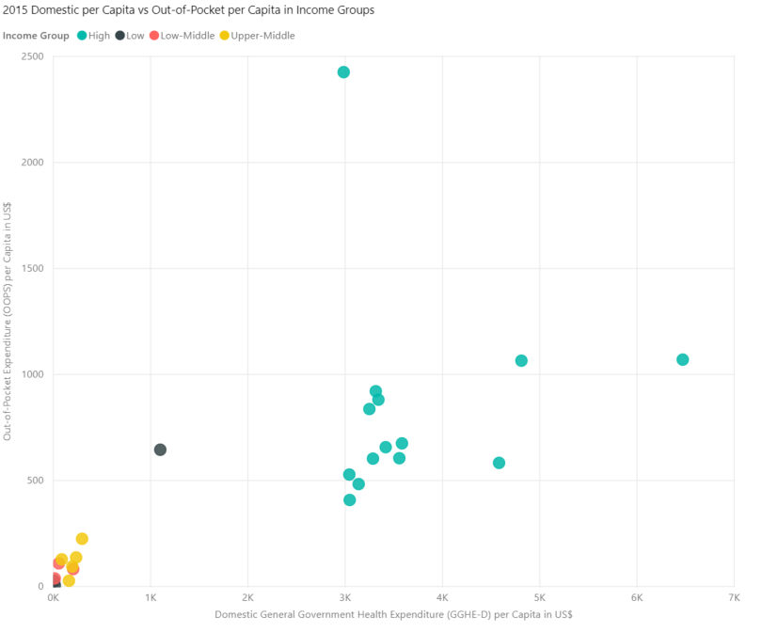

To see the data in more detail and get a better idea, I limited the list of countries to a fewer number of countries and chose to just look at the 2016 out-of-pocket expenditure. This shows that the US does have the highest out-of-pocket costs, but Switzerland comes in a close second, which shows that the US is not the outlier. The US and Switzerland do have quite larger out-of-pocket expenses compared to the next highest country.

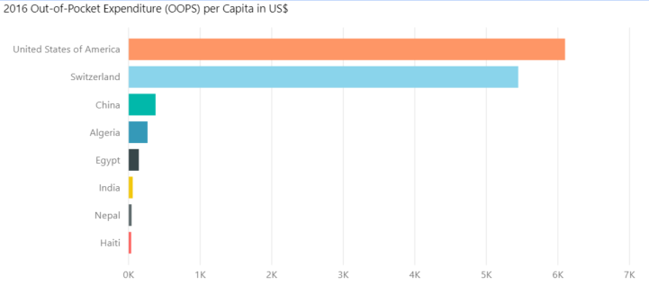

This last stacked bar graph shows the out-of-pocket expenditure per capita by income groups for the same list of countries from above.

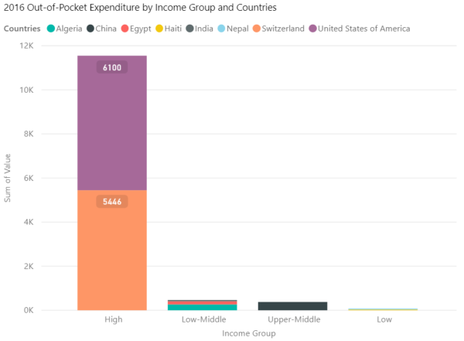

This shows that the US spends about the same as Switzerland does and that there is obviously a clear difference between high-income level countries and all the other income levels.

All of these visuals show that the countries of higher income levels spend more on healthcare and out-of-pocket expenses are higher as well. Countries of lower income levels have lower government expenditure and people have lower out-of-pocket costs as well. The visualizations show that the US is not an outlier and is not the only country spending so much on healthcare. I discovered that in lesser developed countries, the government is spending less on healthcare than developed countries and people are spending less out-of-pocket than more developed countries. This could be due to a lot of factors. Studies and research online could be taking into consideration other factors like obesity, diabetes and other health factors.

**Discussion**

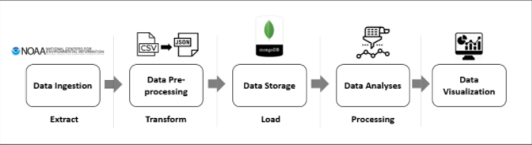

I implemented a pipeline using the things I learned during this semester. The pipeline has the stages of extract, transform, load and processing. Extracting is the process of downloading and reading data from a database. For this I downloaded data from the WHO website as mentioned in the first section of this paper. Transform is the process of converting the extracted data from its previous form into the form it needs to be in, so I used the script.py file that I wrote and ran it to convert the .csv files to .json files. I then imported that json file into MongoDB.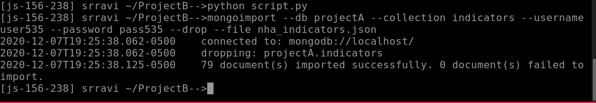

I used the same MongoDB database from the last project and used the new collection that I created called ‘indicators.’ The next stage is load and this is the process of moving the transformed data into the target database, which was MongoDB. The next stage is processing, and this is where the data file was generated by running a query. For the processing stage, I logged onto the MongoDB server and made sure the data loaded. I ran some queries to look at the data and see what data I wanted to keep for the next steps. After practicing querying in MongoDB, I ran a query that included the columns I wanted to keep and I kept all the rows so I did not include anything in the ‘-q’ section of the query.

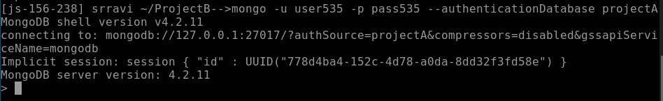

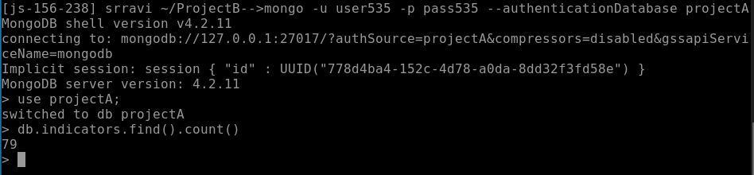

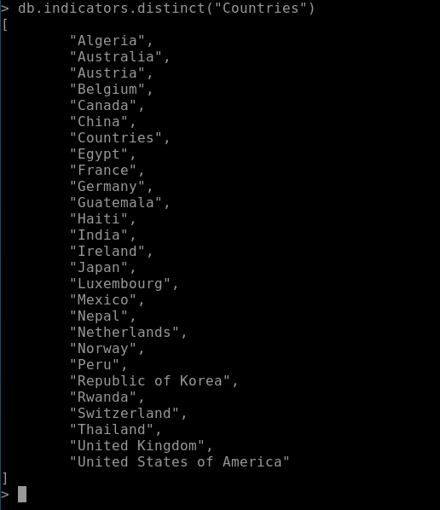

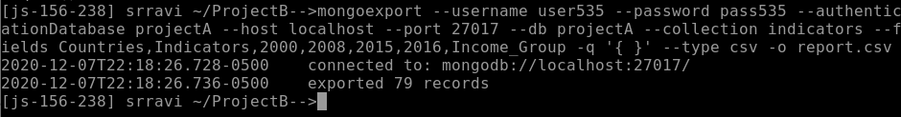

The final stage is to create a data visualization. Data visualizations can be powerful when done correctly and help present a large amount of data in an easier form to understand and I discussed those in the results section. I chose to use PowerBI because I have the most experience with it.

I had some difficulties with writing the scripts for the pipeline in Python. I have experience with Python, but I have not had to use them with noSQL. I had to rewrite the script numerous times because even if the script was doing what it was supposed to, the rows did not get separated in a way that MongoDB could read it. The other issue I had was when JetStream was not working on Friday due to the power outage. It took me some time to get it back up and running.

**Conclusion**

The purpose of this project was to look at the comparison between a country’s expenditure on healthcare and the peoples’ out-of-pocket payments. I downloaded the data from the WHO website and worked through the steps of the pipeline using a Python script file, MongoDB and PowerBI. The results of this showed that people do not spend less out-of-pocket when a government spends more on healthcare, but this could be due to a wide number of reasons that were not taken into consideration for this. If this project were to be done again in the future, I would also look at trends in other health factors that might lead to explanations for the results I got.

**References**

Berezoq, Alex. “Cost & Payments: Two Peculiarities of US Healthcare Spending.” *American Council on Science and Health*, 30 November 2020.

Bloom, Ester. “Here’s How Much the Average American Spends on Health Care.” *CNBC,* CNBC, 30 November 2020.

Ducharme, Jamie. “The U.S. Spends Twice As Much On Health Care As Other High-Income Countries.” *Time,* Time, 3 Dec. 2020.

“Global Health Expenditure Database.” *World Health Organization,* World Health Organization.

OECD (2018), Health spending (indicator). doi: 10.1787/8643de7e-en (Accessed on 5 December 2020).

“Out-of-Pocket Payments, User Fees and Catastrophic Expenditure.” *World Health Organization,* World Health Organization, 5 Dec. 2018.

Rizzo, Kevin. “How Much Does the Government Spend on Health Care?” *Law Street,* 4 Dec. 2020.

Sawyer, Bradley, and Cynthia Cox. “How Does Health Spending in the U.S. Compare to Other Countries?” *Peterson-Kaiser Health System Tracker,* Kaiser Family Foundation, 4 Dec. 2020.